EXPERIMENT 6: EXPERIMENT WITH DIFFERENT LAYOUTS AND COLOR SCHEMES FOR AN APP. COLLECT USER FEEDBACK ON AESTHETICS AND USABILITY

Name: Jovitha J Roll number: 240701219

Aim:
The aim of this experiment is to design and evaluate different layouts and colour schemes for a mobile application and to collect user feedback on aesthetics and usability. The purpose is to explore how variations in visual design influence user perception, ease of navigation, and overall satisfaction, while demonstrating the importance of iterative refinement in creating user-friendly interfaces.

Layout 1:
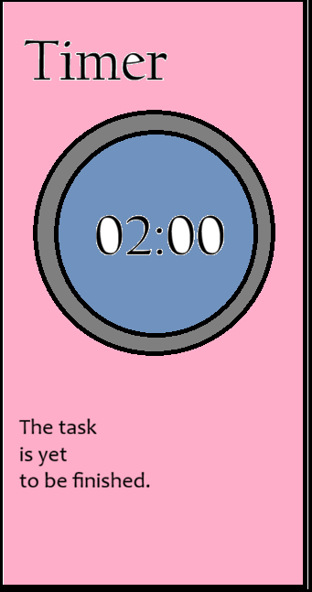

Layout 2:
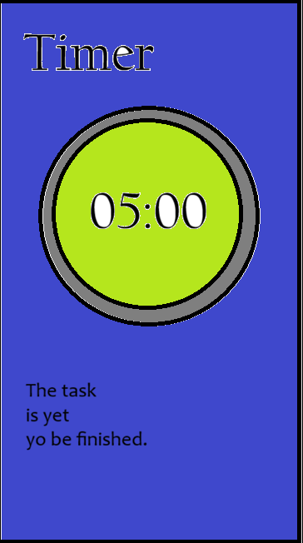

Feedback:

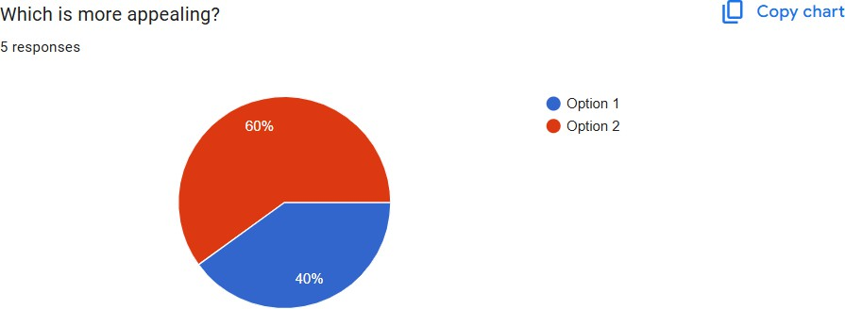

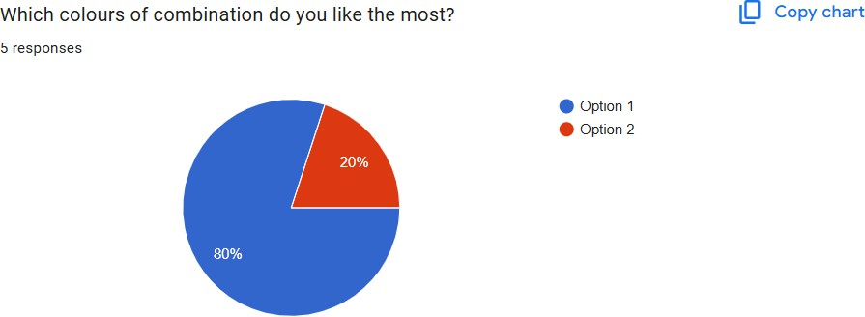

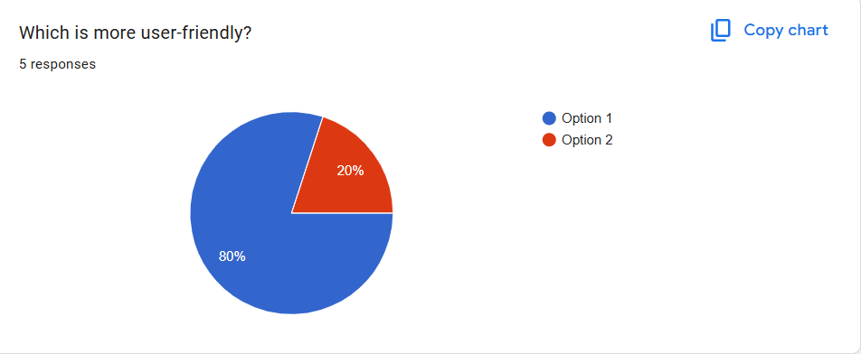
Result:
The experiment showed how varying layouts and colour schemes directly influence user perception of an app’s aesthetics and usability. Feedback revealed which designs were more intuitive and visually appealing, guiding refinements toward a user-centric interface. This highlights the importance of iterative design and user involvement in achieving both functional clarity and engaging visual appeal.

